Project Planning Phase
Project Planning Template (Product Backlog, Sprint Planning, Stories, Story points)

Date | JUNE 2026
Team ID
Project Name | Plugging into the Future: An Exploration of Electricity Consumption Patterns
Maximum Marks | 5 Marks

Product Backlog, Sprint Schedule, and Estimation (4 Marks)
Sprint | Functional  Requirement (Epic) | User Story  Number | User Story / Task | Story Points | Priority | Team  Members
Sprint-1 | Data  Understanding | USN-1 | As a data analyst, I want to collect the Plugging into the Future: An Exploration of Electricity Consumption Patterns dataset. | 2 | High | BYRI MOHAN KUMAR
Sprint-1 | Data Preprocessing | USN-2 | As a data analyst, I want to clean and preprocess the dataset. | 3 | High | BYRI MOHAN KUMAR
Sprint-1 | Data Analysis | USN-3 | As a data analyst, I want to explore trends by region and site type. | 2 | Medium | GADDAM OBULESH
Sprint-2 | Visualization | USN-4 | As a user, I want to visualize global site distribution on a map. | 3 | High | GUDAPAREDDY GOWTAMI
Sprint-2 | Visualization | USN-5 | As a user, I want bar charts showing number of sites by country/year. | 3 | High | SHAIK SUHAIL BASHA
Sprint-2 | Insights | USN-6 | As a user, I want to identify trends in inscription years and site types. | 3 | Medium | VEMULA YESWANTH
Sprint-2 | Deployment | USN-7 | As a team, we want to publish and share the Tableau dashboard effectively. | 4 | High | BYRI MOHAN KUMAR
Use the below template to create product backlog and sprint schedule

Project Tracker, Velocity & Burndown Chart: (4 Marks)
Sprint | Total Story Points | Duration | Sprint Start Date | Sprint End Date (Planned) | Story Points  Completed (as on  Planned End Date) | Sprint Release Date (Actual)
Sprint-1 | 7 | 5 Days | 19 JUNE 2026 | 24 June 2026 | 7 | 19 June 2026
Sprint-2 | 13 | 5 Days | 24 June 2026 | 29 June 2026 | 13 | 24 June 2026

Velocity:
Imagine we have a 10-day sprint duration, and the velocity of the team is 20 (points per sprint). Let’s calculate the team’s average velocity (AV) per iteration unit (story points per day)
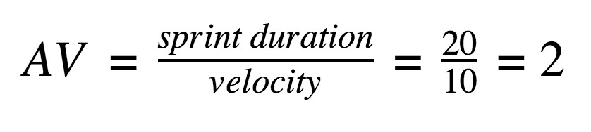
Burndown Chart:
A burn down chart is a graphical representation of work left to do versus time. It is often used in agile software development methodologies such as Scrum. However, burn down charts can be applied to any project containing measurable progress over time.

https://www.visual-paradigm.com/scrum/scrum-burndown-chart/
https://www.atlassian.com/agile/tutorials/burndown-charts

Reference:
t
https://www.atlassian.com/agile/projec
-
managemen
t

https://www.atlassian.com/agile/tutorials/ho
w
-
t
o
-
d
o
-
scru
m
-
wit
h
-
jir
a
-
softwar
e

https://www.atlassian.com/agile/tutorials/epic
s

https://www.atlassian.com/agile/tutorials/sprint
s

https://www.atlassian.com/agile/projec
t
-
management/estimatio
n

https://www.atlassian.com/agile/tutorials/burndow
n
-
chart
s

